RFIC Solutions

🔹 Definition
# Source: ScreenShots Source: Provided by: [Persons Table -> ID Column: 1, Name_En Column: Motasem Essam] -> Tool: [Lightshot Program] -> From [Site: https://rficsolutions.com/] on [1/23/2026]
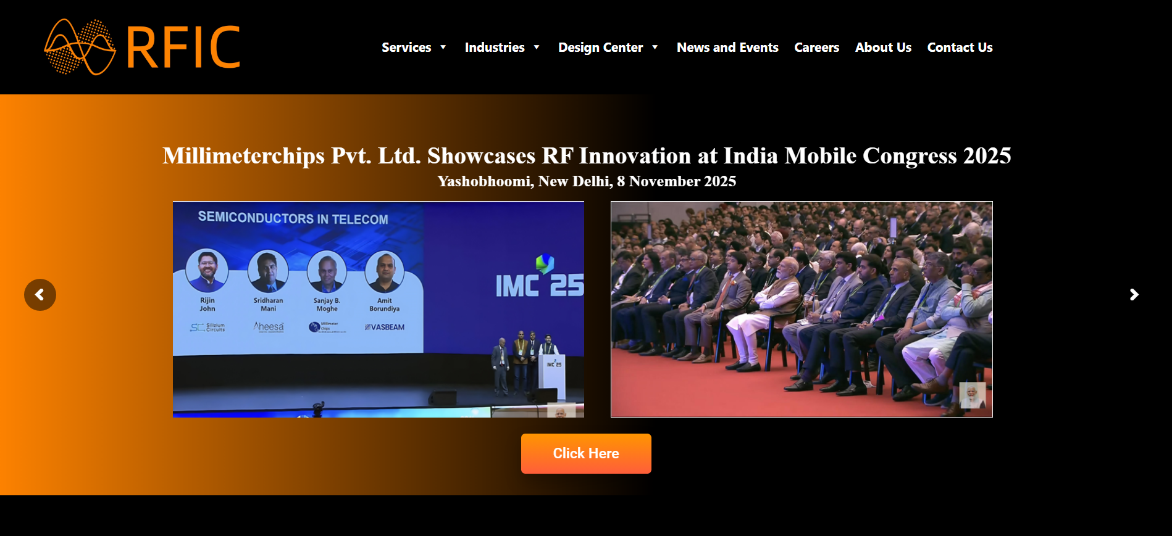
# Source: AI Source: Provided by: [Data Path: Persons Table -> ID Column: 1, Name_En Column: Motasem Essam] -> From: [ChatGPT] on [1/23/2026]
RFIC Solutions (from https://rficsolutions.com) is a fabless semiconductor design company that specializes in radio frequency (RF), microwave and millimeter-wave integrated circuit (IC) and system design for wireless communication applications. (rficsolutions.com)

📌 What the Company Does
# Source: AI Source: Provided by: [Data Path: Persons Table -> ID Column: 1, Name_En Column: Motasem Essam] -> From: [ChatGPT] on [1/23/2026]
- RF & Microwave IC Design: They design custom RFICs, MMICs (monolithic microwave integrated circuits), system-on-chip (SoC) and system-on-package (SOP) solutions using technologies such as GaAs, GaN, SiGe BiCMOS and Silicon CMOS. (rficsolutions.com)
- Component and Subsystem Development: Their portfolio includes components like low noise amplifiers, power amplifiers, mixers, switches, phase shifters, antennas and complete transceiver systems for wireless systems. (rficsolutions.com)
- Services: They provide IP cores, custom IC design, RF PCB and module design, beamforming and phased-array antenna services, and related integration and assembly services. (rficsolutions.com)
- Technology Expertise: RFIC Solutions leverages a range of semiconductor processes and has experience across RF to mmWave frequency ranges, serving industries including 5G, SATCOM, IoT, Wi-Fi (including Wi-Gig) and backhaul systems. (rficsolutions.com)

📍 Background and Structure
# Source: AI Source: Provided by: [Data Path: Persons Table -> ID Column: 1, Name_En Column: Motasem Essam] -> From: [ChatGPT] on [1/23/2026]
- Founded: 2005
- Founders/Leadership: Dr. Sanjay Moghe (CEO) and Ashish Shrotriya (VP of Sales and Operations) (rficsolutions.com)
- Headquarters and Offices: Based in the United States (Florida/Milpitas, California area historically) with engineering/design centers in India. (rficsolutions.com)

🧠 Business Model
# Source: AI Source: Provided by: [Data Path: Persons Table -> ID Column: 1, Name_En Column: Motasem Essam] -> From: [ChatGPT] on [1/23/2026]
RFIC Solutions operates as a fabless design house, meaning it focuses on design and engineering of RF semiconductor IP and devices rather than owning semiconductor fabrication facilities. They partner with foundries worldwide to produce chips based on their designs. (rficsolutions.com)

🛠 Typical Applications
# Source: AI Source: Provided by: [Data Path: Persons Table -> ID Column: 1, Name_En Column: Motasem Essam] -> From: [ChatGPT] on [1/23/2026]
Their technologies are used in systems needing high-frequency wireless communication, including:
- 5G wireless infrastructure
- Satellite communication (SATCOM)
- Fixed wireless access
- IoT and Wi-Gig applications
- Radar and other RF/microwave systems (rficsolutions.com)

